LIVE BY THE TEAM

By Cindy Skaggs

Press Kit
LIVE BY THE TEAM: 2
INTERVIEW: 3
BIOGRAPHY: 8
LINKS: 9
BUY LINKS: 9

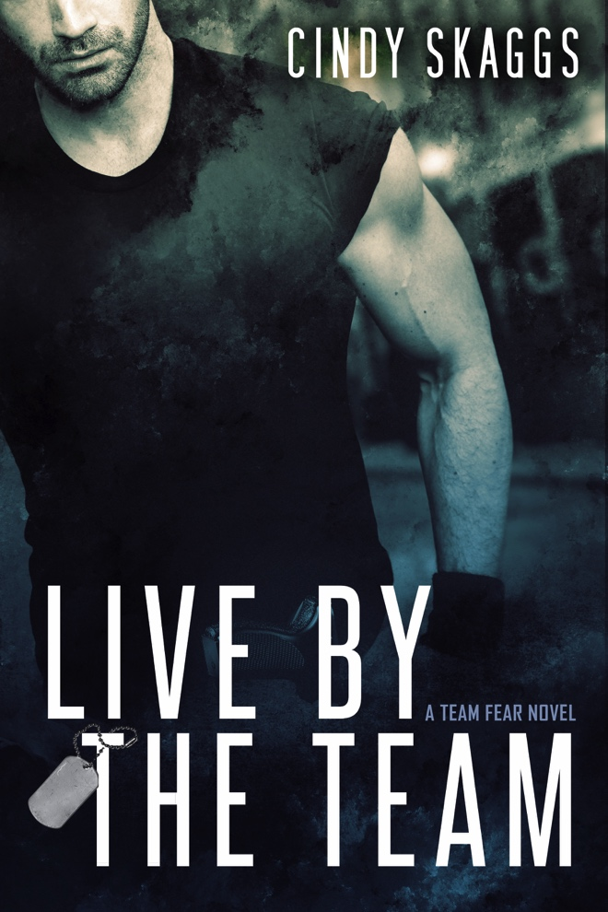
LIVE BY THE TEAM:
They created a monster. Trained by the army, enhanced by medical experimentation, and tested in war. What happens to the creature when the war ends and the man awakens?
SSgt. Ryder was born, bred, and enhanced as a warrior, but when he returns home to his new wife—exiled from the army along with the rest of his disgraced team—he faces mounting anger and paranoia. When a fellow soldier does the unthinkable, Ryder disappears to protect his wife, but his departure leaves a vacuum filled with danger. Can he save her or will he lose himself to the beast and destroy what matters most?
Abandoned most of her life, Lauren Ryder married thinking she had finally found stability, until her new husband disappeared. He returns altered and secretive. Can she forgive him for crushing her dreams of picket fences and happily ever after? Will she survive what he has become?

The surviving members of Team Fear are out of the military and in a world of secrets, lies, and cover-ups in this new romantic suspense series by Cindy Skaggs.

INTERVIEW:

Q: Please tell us about Live By The Team and what inspired you to write it.
A: Every book starts with a character for me, and for this book, that character was Ryder. He’s a badass, a little dark, and a lot sexy. He’s prior military, accustomed to leadership, and trying to keep his disgraced Army team together while their world falls apart. I had this image of him in the desert at sundown walking into a live crime scene, snapping the yellow tape, and putting himself between the police and whoever was involved in the standoff. He lifts his shirt (women everywhere fan themselves) to prove he isn’t armed or dangerous. “Well, the dangerous part was open for interpretation.”
Lauren is a good foil for him. She’s strong-willed, independent, and highly intelligent with a hint of insecurity and a fear of being alone. She’s a history professor and a PhD candidate, because even smart girls deserve love. She’s not above challenging Ryder’s arrogance, and she’s been known to threaten to gut him and filet him for dinner, but at the end of the day, he’s the one man who can give her the love she craves. Together, they seriously heat up the page!
As I delved into the writing, I realized that what drew me to the story was a fascination with fear. Untouchable, my debut novel, went deep into the main character’s fear, which at one point is immobilizing. The men of Team Fear are the exact opposite. They charge head-on at fearful things. Studying fear has become an academic focus for me, so it was only natural that my fiction would take on a new aspect of fear. I’m in awe of the men and women of the military, police, fire, and other first responders who charge towards the trouble the rest of us run from.
Q: What themes do you explore in Live By The Team?
A recurrent theme for me revolves around abandonment and trust. Lauren’s father died fighting in Iraq when she was a kid, and her mother never emotionally recovered. Lauren is determined not to make her mother’s mistakes, so when Ryder disappears; she’s ready to write him off. What does it take to trust? What does it take to risk it all for love, even your most visceral fear?
The other theme that is prevalent in this particular story is home. I know firsthand the difficulty of moving every few years with military orders, leaving behind friends, family, and all that is familiar. The physical location changes every few years for military members, so what makes a home? Is home a place or is it people?
Q: I understand you have an aggressive writing schedule. Are you exhausted? Do you still enjoy writing?
A: Yes. Yes it is exhausting, but also thrilling. From October – December of 2015, I wrote 2 category romantic suspense novels plus a novella in the Untouchable series that are all now with my editor at Entangled, and after seriously stretching my legs as a writer, I didn’t want to slow down. The Team Fear idea had been percolating for quite some time, and this was the perfect time to work on it.
Writing is a puzzle for me. I setup a schedule where I can write close to 20 hours a week plus my MFA homework, my regular job, and teaching night classes at a local college. Oh, yeah, plus the kids and the pets and the rest of life as we know it. It is exhausting, but in the best possible way. Even when I’m struggling with a scene, I’m happy that I have the ability to do what I love most. I hope I always feel the joy of sitting down to the computer, putting in my ear buds, and zoning at to my make-believe world.
Q: What is your most challenging aspect of writing?
A: Starting. Until I have that clear vision in my head of the characters and the opening of the story, I resist. I listen to a playlist for every book or series that I write, and I play it all the time to immerse myself in the emotional mindset of the characters. This stage is the only time that I can’t read anyone else’s work because I need that sole focus on the incoming book. The funny thing is, I forget this every time, and every new book creates this same sad frustrating cycle until something clicks and the characters start taking on a life of their own.
Q: Describe your typical writing day?
A: I drop the kids at school and head to a coffee shop where I meet a couple of my writing friends (as often as we can all get there, anyway). We use writing sprints to keep us motivated, writing for 30 minutes at a time and comparing output. It’s not as competitive as it sounds. Mostly, we’re encouraging each other to write more and better. Sometimes the process changes when someone has a book coming out and wants to talk about publicity, promotion, and Indie publishing, but for the most part, we’re there from 10-3 to get writing done, and all of us have improved the quality and the quantity of our work this way. Writing sprints have liberated me as a writer, because if you’re writing fast, you don’t have time to get in your own way.
Q: What’s the happiest moment you’ve lived as an author?
A: That changes with each project, but right this second, it’s Indie publishing the Team Fear series. It is flying without a net, terrifying and thrilling, but worth the ride.
Q: Is writing an obsession to you?
A: Absolutely. I get cranky (what a nice word) when I don’t write. The truth is, I become a raving witch and my children run as fast and as far as they can. My son calls it “caving” when I need to write. “Are we caving tonight?” he’ll ask, and it gives me permission to hide in my cave to write. Writing helps me get through all the crap in my head so I don’t take it out on those closest to me. I could give up wine and coffee and even the gym (well, actually, that wouldn’t take much incentive), but I could never give up writing. I honestly believe I’d go crazy without the ability to create fictional worlds and fictional characters.
Q: Ray Bradbury once said, “You must stay drunk on writing so reality cannot destroy you.” Do you agree?
A: Truth. I cannot speak for other writers, but for me, reality isn’t such a great concept. I think that’s true for many creatives. It’s why we create. If I became too much of a realist, my ability to write would disintegrate. I can handle a cruel and unjust fictional world, but a cruel real world will send me to the nearest tub of Ben & Jerry’s.
Q: Do you have a website or blog where readers can find out more about you and your work?
My blog is a little like my happy place. I love to see people there, digging through my brain for the newest relevant or irrelevant (or irreverent) post. And I love to engage in conversations (so please post and comment). http://www.cskaggs.com/see-cindy-write I have recently added a writer’s tab to my website where I post writing related topics. I’ve started and continue to facilitate a local writing group, and it’s our place to post on what we’ve discussed each month, but I think the information is valuable for writers everywhere. http://www.cskaggs.com/writers
Q: How has your upbringing influenced your writing?
My dad was significantly older than my mom, and consequently, he died when I was still a kid. It flattened me, so I buried myself in books, starting with Nancy Drew. As a Pisces and a dreamer and an (un)realist, I lived in my dreamworld. I could create fiction out of any environment and lived there. It protected me as a child, and insulated me as an adult. I think the ability to live in fiction is a gift, but others would say it’s a curse, because I have a hard time facing unpleasantness (why would I do that when I can read a book!?).
Q: When and why did you begin writing?
My first short story was written in the 5th grade as a result of a creative writing prompt. I doubt Mr. Pittman meant for it to affect my life in the way that it did, but I wrote a three-page short story about my class being stuck on a cruise ship in the Bermuda Triangle. I, obviously, was the heroine of the story (yes, I saved my class’s fannies). I wrote it out, on purple paper with purple ink, and I wore an actual dress (gasp) to read it aloud to the class. After I finished, Mr. Pittman said, “Now I see why you dressed up.” From that point forward, I knew I’d be a writer (even if I always thought it in the future tense).
Q: Do you recall how your interest in writing originated?
It was an extension of my reading, and it started young. I read Nancy Drew from a young age, and in the 4th grade in Mr. Neis’s class, I started reading The Little House on the Prairie books (which led to a long stage of historical fiction writing). When I was 13, my mother’s Aunt Ilene gave me a brown grocery bag filled with Harlequin romances, and I was hooked. She taught me that you “hid” your “trashy” romances, and that the super-hot doctor always fell for the awkward nurse/patient. I knew I wanted to create a world that existed outside reality and that ended Happily Ever After.
Q: When did you first know you could be a writer?
I finished my first novel in high school. I never showed it to a soul, but through my historical, Civil War, “epic” romance, I learned that I could complete a novel. Unfortunately, I never gave myself permission to pursue writing as a career. After high school, I joined the Air Force. After the Air Force, I got a “paying” job. I went back to college, and still didn’t give credence for my desire to write. After I had kids, I “didn’t have time to write.” In 2011, I finally gave myself permission to write, and I applied to the Creative Writing program at Regis University. That’s when I finally knew that my desire to write could become a payable and pursuable career choice. Others probably don’t need as much validation, but I’m nothing if not persistent in my resistance.
Q: What genre are you most comfortable writing?
Like my reading, my writing is all over the card catalog. The best thing about getting a Masters in Creative Writing is the expansion of your awareness as a writer. It forces you to work in other genres, and I learned that I didn’t hate them. ☺ I write literary nonfiction, and wouldn’t have known what it was if I hadn’t gone back to school. I absolutely love it. It feels very natural to write as myself (something I always thought I wouldn’t do), but romance was my first love in writing, and I’m still most comfortable there. I like the cadence and the patterns and the HEA.
Q: Did writing Live By The Team teach you anything and what was it?
Fabulous question. It taught me to face my fears and it taught me to take risks, both of which of have to do with Indie publishing and believing in my story and myself. The characters always teach me things, an unexpected and sometimes unwanted revelation. Lauren is very self-motivated and self-contained. She doesn’t need a man, but man-oh-man, does she want Ryder. It’s hard for her to give up her perceived independence and start acting as a partner, and I realize I have some of those same pig-headed tendencies. I need to learn to accept help and work together rather than independently all the time.
Q: What is your favorite quote from Live By The Team and why is it your favorite?
Asking me to pick one line out of 85,000 words is a little like asking me to pick a favorite child, but in the interests of fairness, the first line that comes to mind is something I tell my kids all the time: Love is an action word. Ryder is a smooth talker, he can quote poetry, and The Art of War, and naughty limericks, and Lauren is easily swept away the first time, but after he disappears for six months, she’s gotten a little hard. A little bitter. “Love is an action word, Ryder. Your sweet words don’t buy you a pass.”
Q: Who is your biggest supporter?
My kids. I cannot tell you how fabulous it feels for them to support me, and it’s an interesting role reversal. They tell me all the time that they think I’m a great writer, that they’re proud of me, and that they can’t believe I have more Twitter followers than they do. They’ve known for years that we go without material possessions so that I can pursue my education and my writing, and while they may miss “things,” they’ve never complained. I hope it teaches them to pursue their greatest passion.
In Live By The Team, there’s a line where Ryder asks his army buddy why he joined Team Fear, an experimental program. Rose answers: “Doesn’t matter. I signed the papers and drank the Kool-Aid.” The Kool-Aid is the symbol for what brought them to this point, so in the dedication to my kids, saying I would drink the Kool-Aid means I would repeat any and all of my life choices that led me to them, because they’re worth everything.
Q: Who is your biggest critic?
Me, absolutely. After I finish a book, I’m sure it’s garbage and shouldn’t see the light of day. I have to put it away for awhile before I can read it and evaluate it fairly.
Q: What cause are you most passionate about and why?
My kids, single moms, writing, teaching, and the perfect pair of boots. I work three jobs, go to college, teach college classes, have kids and pets and a house and a car to maintain. All that “work” helped me to focus on what was important to me and what I’m passionate about, which is split evenly between my kids and my writing. All jokes about boots aside, I’m passionate about the inequity in this country that faces single moms as an extension of my own experiences and those of women around me, which has led to my passion for teaching, because I believe education is a way out of the bad place many women find themselves.
Q: What are you currently working on?
Finishing up the Team Fear series. Book 2 continues the story as we follow Rose in the fight against... Well, we’ll just have to see.
Q: Do you have any advice for writers or readers?
Trust your instincts. When you’re younger, you think you have to learn “the rules.” Mostly, I want writers to trust the process. The technical aspects of writing will come the more we read and write, but if we rewrite our book every time someone mentions a “rule,” we’ll kill the book faster than we would if we never wrote another word. And sadly, listening to those “rules” and their advocates can block us from writing at all, and that, my friends, is a tragedy. Trust your instincts. If you believe your writing should go in a certain direction, go that direction and hang the rules.
Q: What are some of your long term goals?
To rule the world...oops, that’s the Evil Cindy’s goal. For me, I want to finish the Team Fear series, and I have another novel, more women’s fiction than romance (no dead bodies) that I’m rewriting as part of my MFA thesis project. Under the category of fame, fortunate, and everything that goes with it, I want to make some best seller lists, maybe get a movie deal, and as long as we’re talking dreams... Nah, those are things I can’t control (even if I do want them). What I want most is to reach readers, and provide for my family. If I could write full time, that would be like winning the lottery.
Q: Are you a different person now than you were 5 years ago? In what way/s?
Not even in the same zip code as I was five years ago. I was an insecure single mom who didn’t know how she’d provide for her kids. Ironically, I lived in fear. All. The. Time. Now I don’t have time for fear. That’s not to say it doesn’t exist, but I’m running around all the time, so fear doesn’t know where to catch me. And I embrace things that scare me, such as Indie publishing this series. Five years ago, I wouldn’t have even attempted it.
Q: Do you have a press kit and what do you include in it? Does this press kit appear online and, if so, can you provide a link to where we can see it?
A: Yes. I have a list of interview questions, my bio, links to my social media sites, plus my cover photo, because, dang, Mayhem Cover Creations did a fab job on that cover!
http://www.cskaggs.com/biography.html
Q: Have you either spoken to groups of people about your book or appeared on radio or TV? What are your upcoming plans for doing so?
A: I established and continue to facilitate a local writers group, so I speak monthly on various writing craft topics as well as critique both fiction and nonfiction. I was recently interviewed on the Creative Magazine Radio Show, and I participated in an annual writing program established by the Pikes Peak Library District called the Mountain of Authors. I enjoy speaking on topics of writing craft and fear.

BIOGRAPHY:
Cindy Skaggs started gambling because she needed a quick financial turnaround for an investment opportunity, and her father was right there to pony up the bankroll. She learned valuable lessons that night in betting, bluffing, and folding, until she’d turned a dollar in nickels into serious money: twelve dollars for a middle school yearbook.
Cindy grew up on stories of mob bosses, horse thieves, cold-blooded killers, and the last honest man. Most of those stories were even true. She has ten siblings, some of whom are older than her mother, has nieces and nephews older than her, and once went to a horse auction with John Wayne. Well, with him in the sense that he was there, and she was also... there. She was the skinny little kid in line for his autograph with tangled hair and bruised knees that liked to dance on her daddy’s dusty cowboy boots and listen to his tall tales.
With her love of storytelling and heroes, it’s no wonder she turned to books and stories after her father died. She skipped most of the eighth grade to bury herself in books while hidden in her closet, because she was still looking for the quick turnaround, the ultimate story, and the last honest man. Her search took her around the world with the Air Force as well as around the world with her education. She’s visited more countries than she can remember, nearly every state in the U.S., and has more degrees than the Tin Man.
As a single mom, she’s still gambling, betting on herself for the first time in her life, turning her lifelong love of storytelling into the one thing she can’t live without: writing. She writes 10,000 words a week in cafes and coffee shops, and some of those are even worth reading. She has an MA in Creative Writing, is working towards her Master of Fine Arts, and has three jobs, two kids, a Pushcart Nomination, more pets than she can possibly handle, and more works in progress than the crew filling potholes after a long Colorado winter.
Facebook is her guilty pleasure (Cindy Skaggs, Writer), the Twitterverse her happy place (@CLSkaggs), and her blog the one place she’s not telling stories (fictional, anyway). This time around, she’s holding out for the last honest man. You can find her at www.CSkaggs.com or read her books available here.
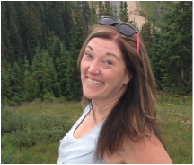
SHORT BIO:
Cindy Skaggs grew up on stories of mob bosses, horse thieves, cold-blooded killers, and the last honest man. Those mostly true stories gave her a lifelong love of storytelling and heroes. Her search for story took her around the world with the Air Force before returning to Colorado.
As a single mom, she’s turning her lifelong love of storytelling into the one thing she can’t live without: writing. She has an MA in Creative Writing, three jobs, two kids, and more pets than she can possibly handle. Find her on Facebook as Cindy Skaggs, Writer, @CLSkaggs on Twitter, or www.CSkaggs.com to sign up for her newsletter.

LINKS:
Website: http://www.cskaggs.com
Facebook: https://www.facebook.com/CSkaggs
Twitter: https://twitter.com/CLSkaggs
Goodreads: https://www.goodreads.com/author/show/14133834.Cindy_Skaggs
Pinterest: https://www.pinterest.com/cindyskaggs/

BUY LINKS:
http://amzn.com/B01EKE78VU

