FIGHT BY THE TEAM (Team Fear 2)

By Cindy Skaggs

Press Kit
FIGHT BY THE TEAM: 2
INTERVIEW: 3
EXCERPT: 4
SHORT BIO 5
LINKS: 5
BUY LINKS: 5

FIGHT BY THE TEAM:
Military trained, medically enhanced, designed to kill.
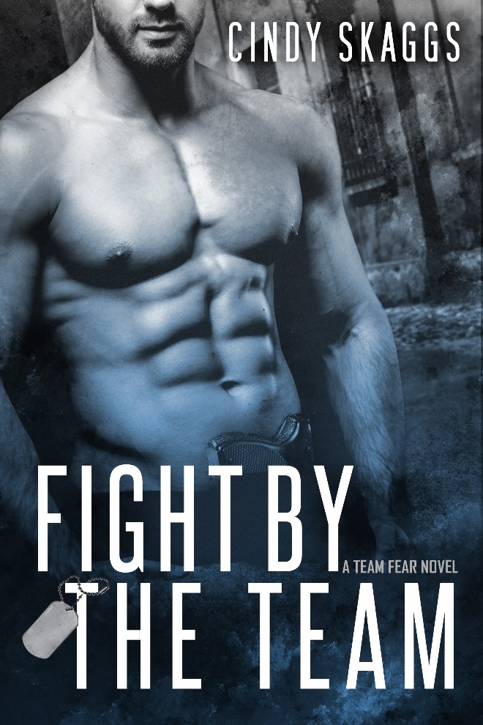
Sergeant Rose is a former Special Forces soldier turned fearless through a classified program designed to inhibit the physiological reactions to fear, but the secret cocktail of drugs has lethal side effects. The soldiers are still fearless, but they’re also angry, paranoid, violent, and potentially suicidal, making them a danger to anyone close to them, which sends Rose on a mission of revenge against the military and the scientists who used Team Fear as guinea pigs to further a twisted agenda.
A discredited chemist fired for rushing testing protocols, Debi works as a bartender and longs for a way to redeem an impulsive, life-altering mistake. When she is kidnapped and nearly killed by the men sent to destroy Team Fear and all evidence of the experimental program, she has no choice but to join Team Fear on their quest for vengeance. Now she’s in the crosshairs of a rogue military team bent on her destruction.
The threat of annihilation should be enough to prevent Rose from acting on his fantasies about the beautiful scientist, but he can’t fight fate, the Army, and their explosive chemistry. As they’re drawn deeper into the conspiracy, will their relationship survive the truth?
Fast paced, with twists and turns and a side of steamy, Fight By The Team is the second in the Team Fear series. The surviving members of Team Fear are out of the Army and in a world of secrets, lies, and cover-ups in this military romantic suspense series by Cindy Skaggs.
The surviving members of Team Fear are out of the military and in a world of secrets, lies, and cover-ups in this new romantic suspense series by Cindy Skaggs.

INTERVIEW:

Q: Please tell us about Fight By The Team and what inspired you to write it.
A: Every book starts with a character for me, and for this book, that character was Rose. In a group of oversized alphas, he’s the biggest and the quietest. “He was the kind of soldier who made you want to enlist in whatever games he wanted to play.” If Ryder (book 1) is the head of the team, Rose is the heart. He’s accepted his mortality and is looking for a little justice before he goes. Attraction to the heroine is an emotional connection he won’t risk, because people close to the team end up injured or dead. Debi is a great foil for Rose. He’s afraid of nothing and she’s afraid of everything. You’ll see.
As I delved into the writing, I realized that what drew me to the story (the series) was a fascination with fear. The men of Team Fear charge head-on at fearful things. I’m in awe of the men and women of the military, police, fire, and other first responders who charge toward the trouble the rest of us run from.
Q: Do you have a website where readers can find out more about you and your work?
Here’s a link to my website: http://www.cskaggs.com/
Q: What is your favorite quote from Fight By The Team and why is it your favorite?
“No fear. A fitting epitaph, more curse than blessing, the truth of their very existence.”
It’s my favorite because it so concisely explains the concept of the Team Fear books.
Q: Are you a different person now than you were 5 years ago? In what way/s?
Not even in the same zip code as I was five years ago. I was an insecure single mom who didn’t know how she would provide for her kids. Ironically, I lived in fear. All. The. Time. Now I don’t have time for fear. That’s not to say it doesn’t exist, but I run around all the time, so fear doesn’t know where to catch me. And I embrace things that scare me, such as Indie publishing this series. Five years ago, I wouldn’t have even attempted it.

EXCERPT:
A muscle twitched in his bicep; otherwise he was still. “You don’t owe me anything.”
“No. But I’d like to.”
“What am I supposed to do with that?” He laced his fingers together on the top of his head. His features were impassive, intimidating as hell. “I decked one of my teammates in anger. Doesn’t that concern you?”
“All you did was split his lip.” The day before, he’d taken Wade out with one hit. “You pulled your punch.”
“That should still concern you.”
“It’s between you and Stills.”
“He’s got a hard face. He’ll live.”
“My point exactly. How about you?” Because the guilt hadn’t left his eyes the whole time they’d talked.
Shallow breaths moved his chest. “Why are you here?”
The coronary that had threatened since she was a kid was about to be realized. The words stalled in her throat, but if he could expose himself, his anger issues and the concerns behind them, she could speak the truth. Crap. Her heart nearly seized. “I want you to sleep in my bed.” She stepped forward and ran a finger down the midline, feeling the muscles twitch. It was quite possible she’d die before he answered. “And I don’t want to snuggle.”

SHORT BIO:
Cindy Skaggs grew up on stories of mob bosses, horse thieves, cold-blooded killers, and the last honest man. Those mostly true stories gave her a lifelong love of storytelling and heroes. Her search for story took her around the world with the Air Force before returning to Colorado.
As a single mom, she’s turning her lifelong love of storytelling into the one thing she can’t live without: writing. She has an MA in Creative Writing, three jobs, two kids, and more pets than she can possibly handle. Find her on Facebook as Cindy Skaggs, Writer, @CLSkaggs on Twitter, or www.CSkaggs.com to sign up for her newsletter.

LINKS:
Website: http://www.cskaggs.com
Facebook: https://www.facebook.com/CSkaggs
Twitter: https://twitter.com/CLSkaggs
Goodreads: http://www.goodreads.com/CindySkaggs
Pinterest: https://www.pinterest.com/cindyskaggs/

BUY LINKS:
https://amzn.com/B01G9738Q0

